**DAILY ONLINE ACTIVITIES SUMMARY**

|  |  |  |  |  |  |  |  |  |
| --- | --- | --- | --- | --- | --- | --- | --- | --- |
| **Date:** | **13/06/2020** | | | | | **Name:** | **Lavanya D M** | |
| **Sem & Sec** | **4th & ‘A’** | | | | | **USN:** | **4al18cs041** | |
| **Online Test Summary** | | | | | | | | |
| **Subject** | | **Data Communication** | | | | | | |
| **Max. Marks** | | **30** | | **Score** | | | **26** | |
| **Certification Course Summary** | | | | | | | | |
| **Course** | **VMware lab** | | | | | | | |
| **Certificate Provider** | | | **Bitdegree** | | **Duration** | | | **1 week** |
| **Coding Challenges** | | | | | | | | |
| **Problem Statement:1)** Write the java code to find the first non-repeated character of a given String  **2)**  Write a C Program to calculate Electricity Bill | | | | | | | | |
| **Status: complied** | | | | | | | | |
| **Uploaded the report in Github** | | | | | **yes** | | | |
| **If yes Repository name** | | | | | <https://github.com/lavanyamurthi/lockdown-coding/tree/master> | | | |
| **Uploaded the report in slack** | | | | | **yes** | | | |

Online Test Details: (Attach the snapshot and briefly write the report for the same)

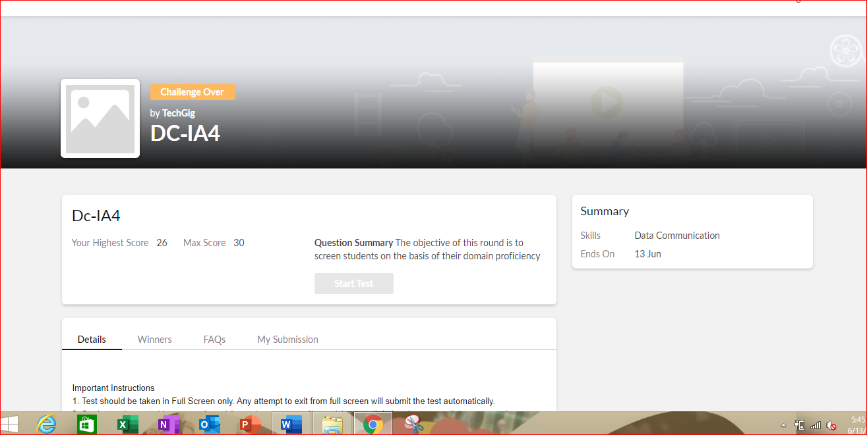

Certification Course Details: (Attach the snapshot and briefly write the report for the same)

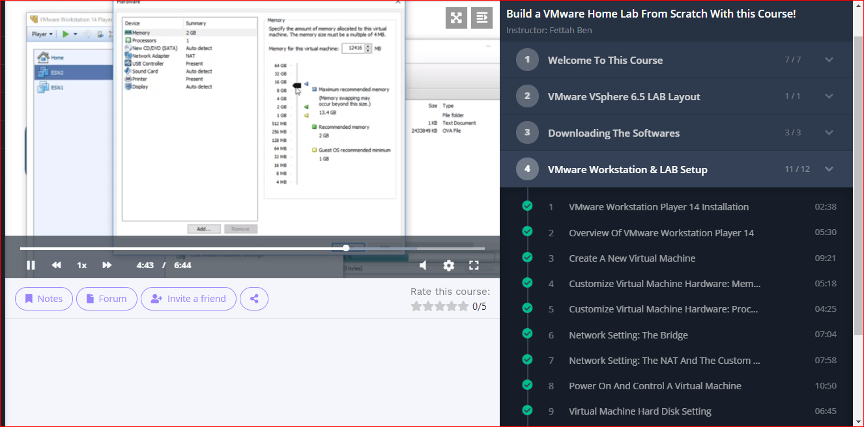

Coding Challenges Details: (Attach the snapshot and briefly write the report for the same)

Problem 1:  Write a C Program to calculate Electricity Bill

Given an integer U denoting the amount of KWh units of electricity consumed, the task is to calculate the electricity bill with the help of the below charges:  
• 1 to 100 units – Rs 10/- Per Unit  
• 100 to 200 units – Rs. 15/- Per Unit  
• 200 to 300 units – Rs. 20/- Per Unit  
• above 300 units – Rs. 25/- Per Unit

**Examples:**

Input: U = 250

Output: 3500

**Explanation:**

Charge for the first 100 units – 10100 = 1000Charge for the 100 to 200 units – 15100 = 1500  
Charge for the 200 to 250 units – 20*50 = 1000  
Total Electricity Bill = 1000 + 1500 + 1000 = 3500

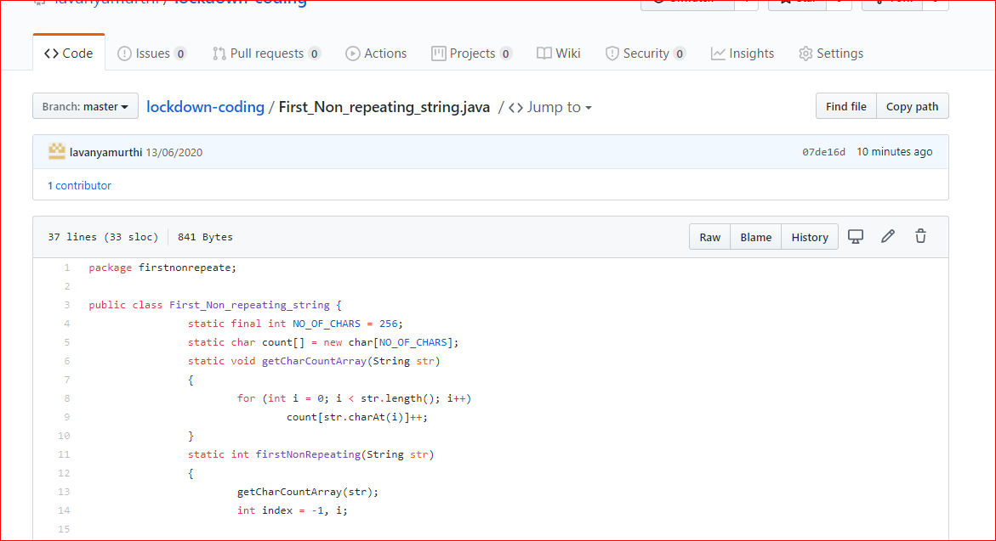

Problem 2: How to find the first non-repeated character of a given String?

Use Java and refer net

